**No Punch Reminder Guideline**

1. Login

Path：<http://app/NOPR/Home.aspx>

UserName/Password：（Same as FIB）

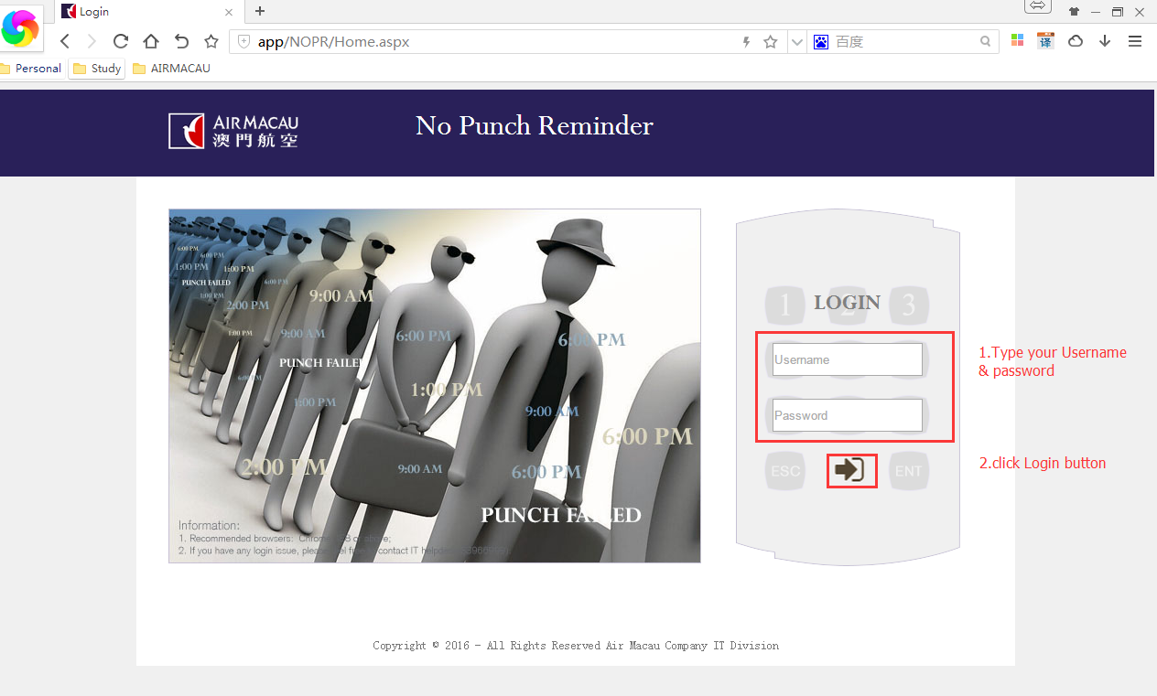

1. Home page

In Home Page you can download EXCEL sample and Guideline

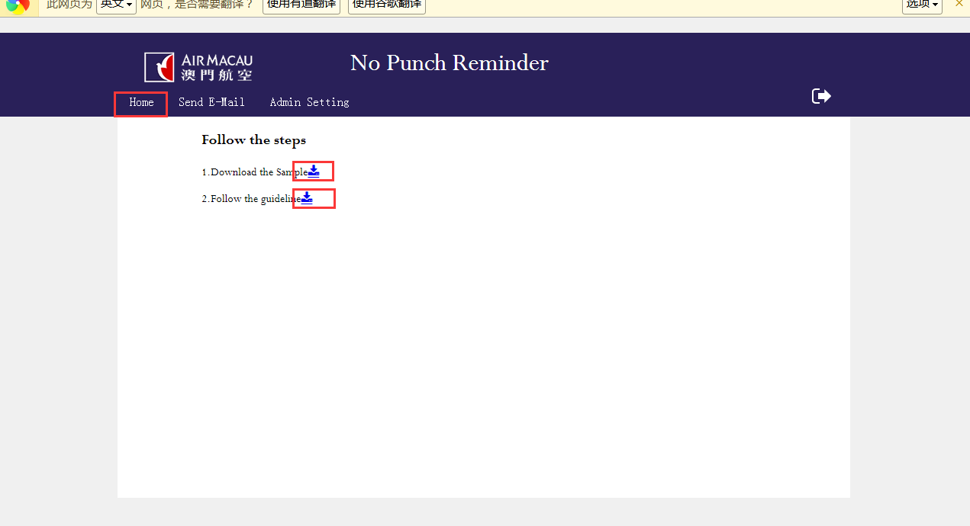

1. Send E-mail

There are two page for different Email

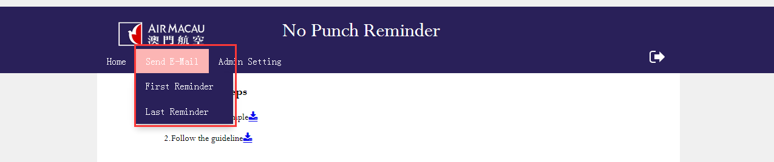

a.select files and upload

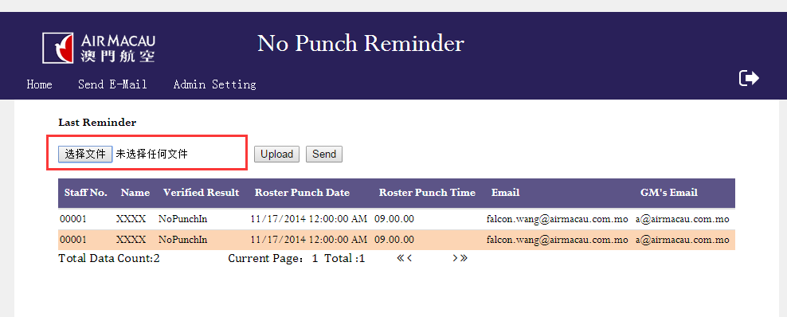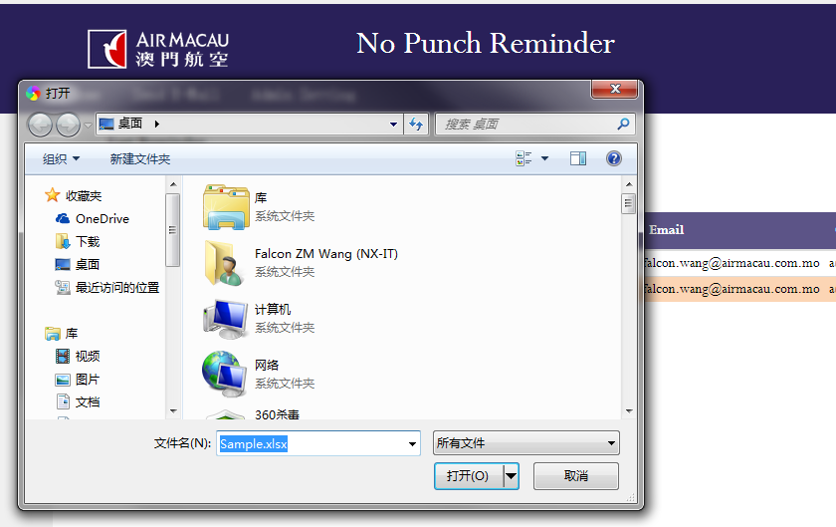

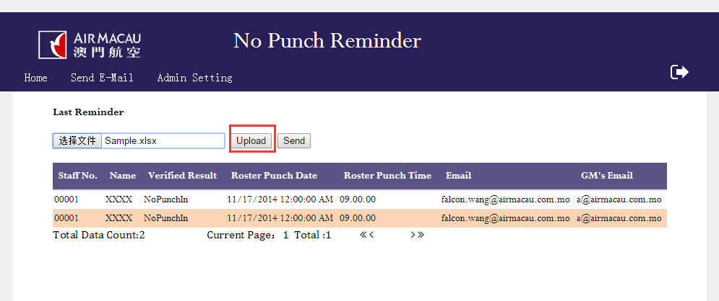

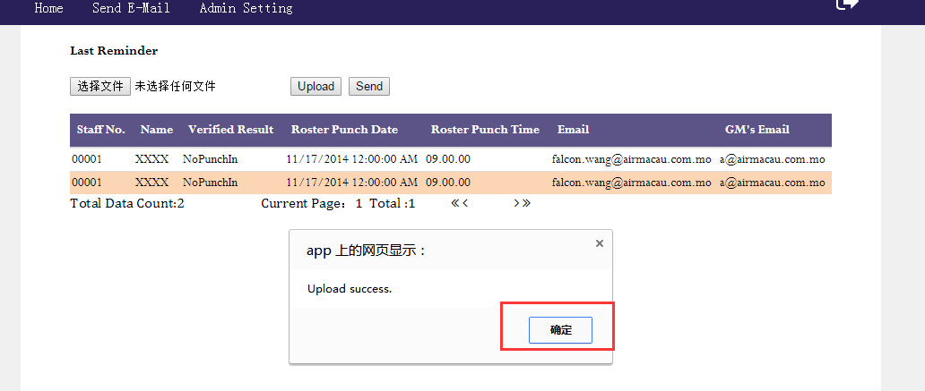

b.preview the data

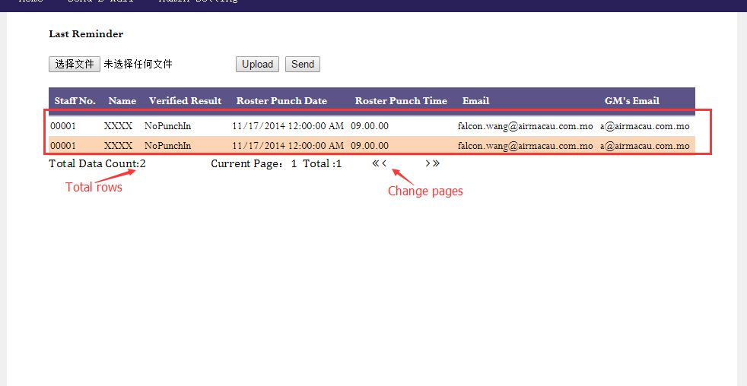

c.confirm to send E-mail

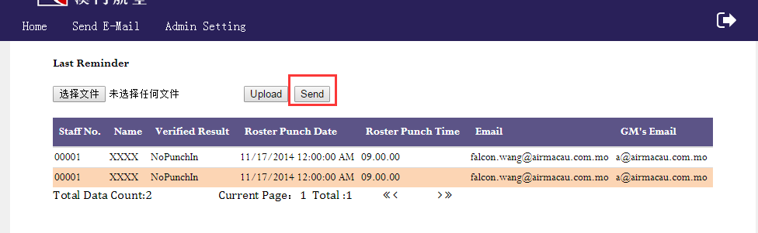

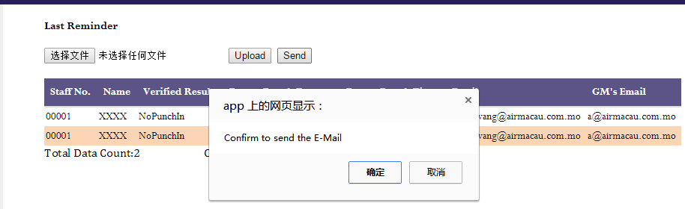

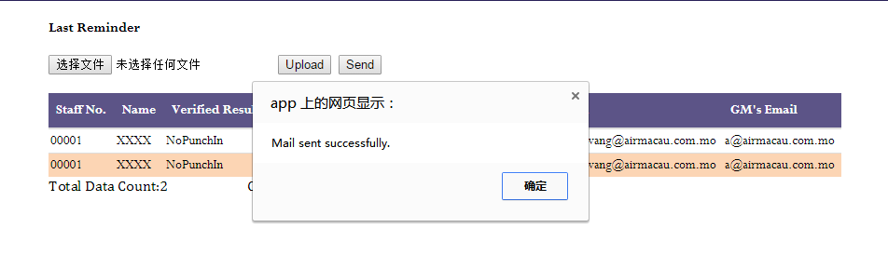

1. Admin setting
2. 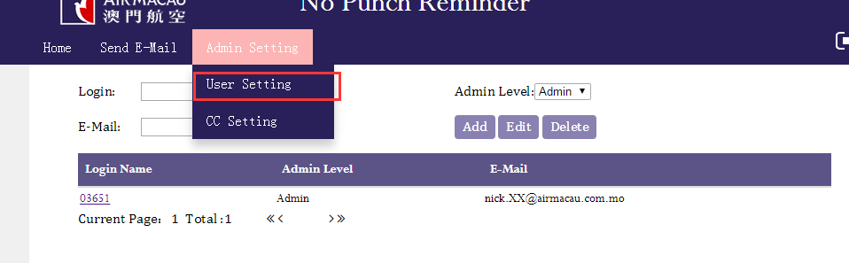
3. add a new user

Login is the staff number, Admin Level(Admin can setting user and cc ,user can only send email), email must be fill in.

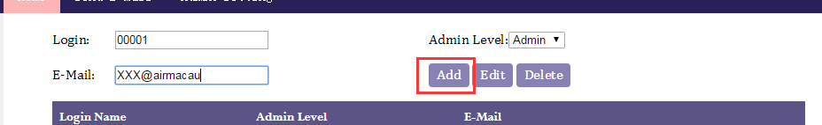

1. edit user
   1. select the user which need to edit

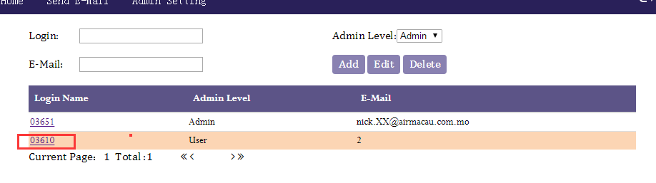

* 1. edit the information

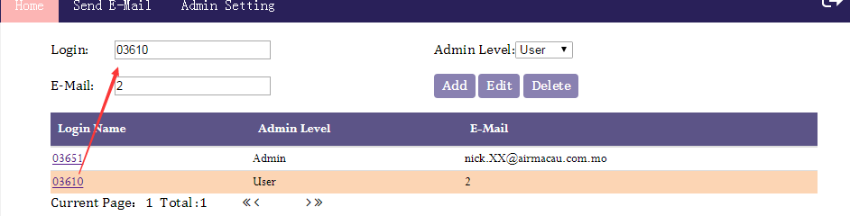

* 1. click edit button

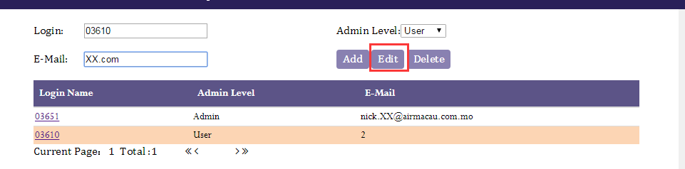 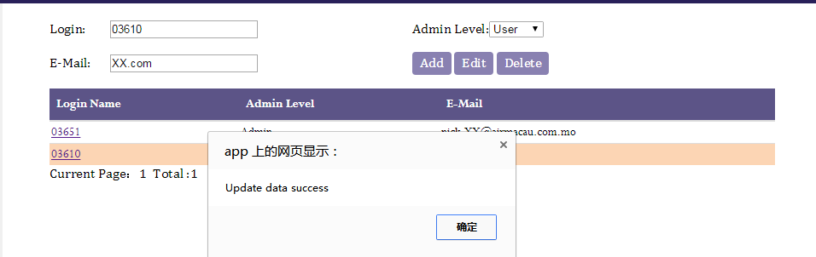

1. delete user
   1. select user

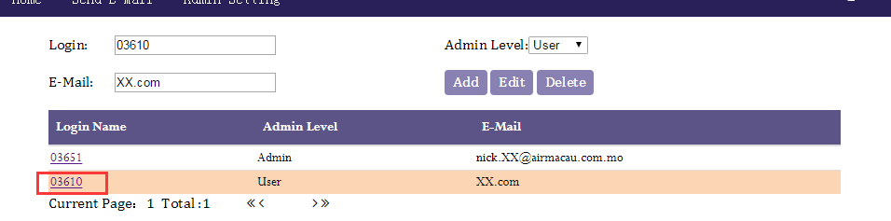

* 1. click delete button

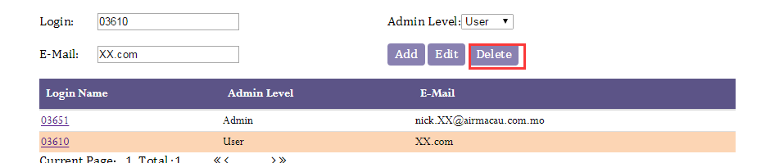 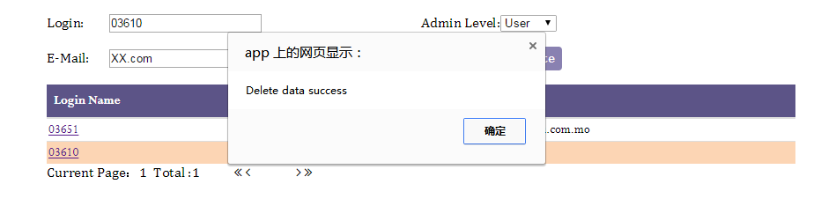

1. CC setting

Input the email addresses and then click OK.

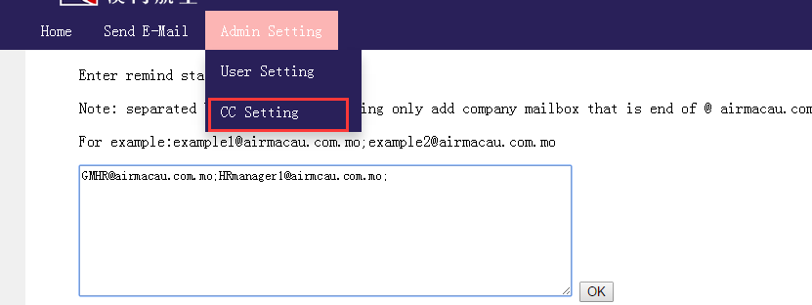

Enter remind staff to receive E-mail

Note: separated by semicolons, allowing only add company mailbox that is end of @ airmacau.com.mo

For example:example1@airmacau.com.mo;example2@airmacau.com.mo

